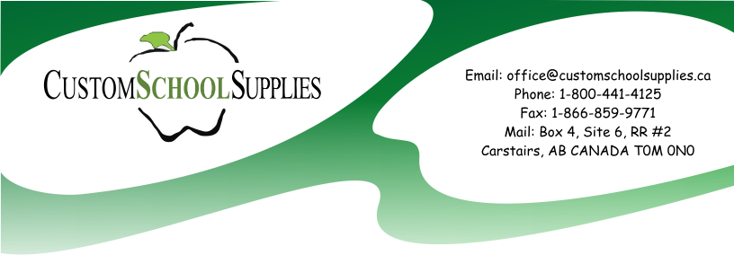

Phone: 403-801-8338

Dear Parents/Guardians:

Custom School Supplies is once again offering the parents of children planning to attend OLDS KOINONIA CHRISTIAN SCHOOL next year the opportunity to pre-purchase their school supplies. We will purchase, package and deliver all of your children's school supplies for the next year. As a part of our service, we also provide a sheet of 80 pre-printed labels personalized for your child. Custom School Supplies has been serving schools and parents in Alberta for over 25 years.

There are a few simple steps to ensure your child will receive quality, standardized brand name products.

- Please visit our website at www.CustomSchoolSupplies.ca

- Click on “Order Now” and then put in the school code: OKCS2023
or use this QR Code

- When you enter your child’s name when ordering, this is the exact name that will be printed on the 80 pre-printed labels personalized for your child.

- You will be able to securely order your child’s supplies online. Payment is verified via Paypal. You will be able to pay with a credit card or if you already have a PayPal account you may choose to pay with your PayPal account.

- Paypal will ask you for a shipping address –although your school supplies will be delivered directly to your school, this is one of the verification process PayPal uses when you pay with a credit card.
Please make sure the address you give exactly matches the address where your credit card bill goes to.

- Your school supplies will be delivered directly to your school, ready for your child when they arrive at school the first day.

- The deadline to complete your order online without penalty is May 31st, 2023.
Online ordering will still be available after the deadline (until August 1st) but may be subject to a $10.00 late fee.

THIS IS A VOLUNTARY PROGRAM but one that we are sure will be of value to you and your school as it ensures that students will be provided with quality school supplies that meet the school’s exact needs. The supplies will be packaged and DELIVERED DIRECTLY TO THE SCHOOL in August before school starts. This will give you one less thing to worry about over the summer and provide you with one less expense in September.

If you have any questions, please contact Custom School Supplies at phone: 403-801-8338 or
email: office@customschoolsupplies.ca

Thank you in advance for considering purchasing your school supplies with Custom School Supplies.

Margi Sayer

CUSTOM SCHOOL SUPPLIES

www.customschoolsupplies.ca
Phone: 403-801-8338

